**Basic Statistics (Module – 4 (Part – 2))**

**Name: Upadhyay Sachin Naresh**

**Batch ID: Data science_08032021**

1. For each of the following statements, indicate whether it is True/False. If false, explain why.
   1. The sample size of the survey should at least be a fixed percentage of the population size in order to produce representative results

True: The representation of the survey results should have a sample size. The sample size must be a fixed percentage of the total population size of the survey

* 1. The sampling frame is a list of every item that appears in a survey sample, including those that did not respond to questions.

False: The sampling frame refers to a list of an item which responds to the question and not the ones which do not respond to the questions.

* 1. Larger surveys convey a more accurate impression of the population than smaller surveys.

True: The larger conveys a more accurate impression of the population as larger

surveys involve large sample size which reduces the chances of error.

1. PC Magazine asked all of its readers to participate in a survey of their satisfaction with different brands of electronics. In the 2004 survey, which was included in an issue of the magazine that year, more than 9000 readers rated the products on a scale from 1 to 10. The magazine reported that the average rating assigned by 225 readers to a Kodak compact digital camera was 7.5. For this product, identify the following:
2. The population

p=x/n=225/9000=0.025

1. The parameter of interest

sample size, average, scale

1. The sampling frame

9000

1. The sample size

225

1. The sampling design

The selection of sample from survey is filtered that is kodak company compact digital camera.

Ex: simple random sample

1. Any potential sources of bias or other problems with the survey or sample

Source is PC magazine

Q3) Suppose we want to estimate the average weight of an adult male in Mexico. We draw a random sample of 2,000 men from a population of 3,000,000 men and weigh them. We find that the average person in our sample weighs 200 pounds, and the standard deviation of the sample is 30 pounds. Calculate 94%,98%,96% confidence interval?

Answer:

Identify a sample statistic. Since we are trying to estimate the mean weight in the population, we choose the mean weight in our sample (200) as the sample statistic

We are working with a 94 % confidence level

Find standard error. The standard error (SE) of the mean is:

=

SE = *s*

*√ n*

30

*√* 2000

= 0.670

= Compute alpha (α): α = 1 - (confidence level / 100) = 0.9933

= Find the critical probability (p*): p* = 1 - α/2 = 1 – 0.9933/2 = 0.4966

= find the degree of freedom (df): df = n-1 = 2000 – 1 = 1999

= The critical value is the t score having 1999 degrees of freedom and a probability equal to 0.4966

= critical value is -0.009

= critical value * standard error= - 0.009 * 0.94 = -0.00846

= - 0.009 * 0.98 = -0.00882

= -0.009 * 0.96 = - 0.00846

1. What are the chances that

*X*  ** ?

1. ¼
2. ½
3. ¾
4. 1

Ans: D

1. A book publisher monitors the size of shipments of its textbooks to university bookstores. For a sample of texts used at various schools, the 95% confidence interval for the size of the shipment was 250 ± 45 books. Which, if any, of the following interpretations of this interval are correct?
2. All shipments are between 205 and 295 books.

INCORRECT

1. 95% of shipments are between 205 and 295 books.

CORRECT

1. The procedure that produced this interval generates ranges that hold the population mean for 95% of samples.

CORRECT

1. If we get another sample, then we can be 95% sure that the mean of this second sample is between 205 and 295.

CORRECT

1. We can be 95% confident that the range 160 to 340 holds the population mean.

INCORRECT

1. Which is shorter: a 95% *z*-interval or a 95% *t*-interval for *μ* if we know that σ =s?
2. The z-interval is shorter
3. The t-interval is shorter
4. Both are equal
5. We cannot say

Answer: C

Questions 8 and 9 are based on the following: To prepare a report on the economy, analysts need to estimate the percentage of businesses that plan to hire additional employees in the next 60 days.

1. How many randomly selected employers (minimum number) must we contact in order to guarantee a margin of error of no more than 4% (at 95% confidence)?

A. 600

B. 400

C. 550

D. 1000

Answer: A

Margins of errors estimates is 1/sqrt(n)

If 0.04 = 1/25 is margin of error

then n= 25^2 = 625.

1. Suppose we want the above margin of error to be based on a 98% confidence level. What sample size (minimum) must we now use?

A. 1000

B. 757

C. 848

D. 543

ANSWER: C

0.04 = 2.32 * √0.6^2/n

n = 2.326^2 * √0.6^2/ 0.42

= 846.35

C is correct one

1. Examine the following normal Quantile plots carefully. Which of these plots indicates that the data?
2. Are nearly normal?

Ans: C

1. Have a bimodal distribution? (One way to recognize a bimodal shape is a “gap” in the

spacing of adjacent data values.)

Ans: B

1. Are skewed (I. e. not symmetric)?

Ans: A, C, D

1. Have outliers on both sides of the center?

Ans: A

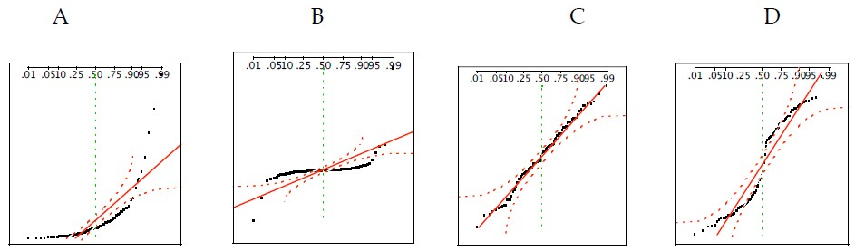

1. For each of the following statements, indicate whether it is True/False. If false, explain why.

The manager of a warehouse monitors the volume of shipments made by the delivery team. The automated tracking system tracks every package as it moves through the facility. A sample of 25 packages is selected and weighed every day. Based on current contracts with customers, the weights should have μ = 22 lbs. and σ = 5 lbs.

1. Before using a normal model for the sampling distribution of the average package weights, the manager must confirm that weights of individual packages are normally distributed.

Ans: TRUE. In this case, at least 30 sample packages must be selected and weighed every day. Based on the central limit theorem, the sampling distribution of the sample mean approach normal distribution as the sample size become bigger (over 30).

1. The standard error of the daily average SE(𝑥̅) = 1

Ans: TRUE. Standard error equal to standard deviation divided by square root of sample size = 5/sqrt(25) =1



1. An educational startup that helps MBA aspirants write their essays is targeting individuals who have taken GMAT in 2012 and have expressed interest in applying to FT top 20 b-schools. There are 40000 such individuals with an average GMAT score of 720 and a standard deviation of 120. The scores are distributed between 650 and 790 with a very long and thin tail towards the higher end resulting in substantial skewness. Which of the following is likely to be true for randomly chosen samples of aspirants?
2. The standard deviation of the scores within any sample will be 120.
3. The standard deviation of the mean of across several samples will be 120.
4. The mean score in any sample will be 720.
5. The average of the mean across several samples will be 720.
6. The standard deviation of the mean across several samples will be 0.60

ANSWER:

The SEM is sd/sqrt(n)=120/sqrt(40000)=0.6

A. SD will not be 120 of scores in any one sample, especially since we don't know the sample size.

B. SD of mean across several samples will also not be 120. It will be less; indeed, probably about 0.6

C. The mean score in any sample will be 720. Maybe, but no reason it couldn't be less or more.

D. The average of the mean across several samples will be 720. This is certainly possible, but it requires the mean of all samples that sample size, which would be the case

E. The SEM will be 0.60. This is likely, given the sample size, which even with a lot of skewness will tend towards normality given the sample size. I would use this in calculations. The mean would have an expected value of 720, but in calculations, the SEM is 0.6.

**Hints:**

1. Business Problem
   1. Objective
   2. Constraints (if any)
2. For each assignment the solution should be submitted in the below format
3. Research and Perform all possible steps for obtaining solution
4. For Basic Statistics explanation of the solutions should be documented in black and white along with the codes.

One must follow these guidelines as well:

* 1. Be thorough with the concepts of Probability, Central Limit Theorem and Perform the calculation stepwise
  2. For True/False Questions, explanation is must.
  3. R & Python code for Univariate Analysis (histogram, box plot, bar plots etc.) for data distribution to be attached

1. All the codes (executable programs) should execute without errors